

**Batch: B–1 Roll No.: 16010422234 Experiment No.:7**

**__________________________________________________________________________**

**Aim:** To Implement the model for Cafeteria using Extend Sim and estimate system performance.

**__________________________________________________________________________**

**Resources needed:** Extend Sim 10.0.7

**__________________________________________________________________________**

**Theory**

**Problem Statement:**

People arrive at a self-service cafeteria at the rate of one every 30 sec (Arrivals are Poisson distributed). 40% got to the sandwich counter, where one worker makes a sandwich in approximately 60 sec. The rest go to the main counter; where one server spoons the prepared meal onto a plate in approximately 45 sec. All the customers must pay a single cashier, which takes approximately 25 sec., for all customers eating takes approximately 20 min. After eating 10% of the people go back for dessert, spending an additional 10 min (approx) altogether in the cafeteria. Simulate until 100 people have left the cafeteria, how many people are left in the cafeteria and what are they doing at the time the simulation ends. Except for the arrivals all the other data are exponentially distributed.

Model the problem as a queuing system.

Animate the model in 2D.

Run the simulation till 100 people have departed from the system.

Plot and verify the following results

* Length of the queue against the number of jobs exited from the system.
* Display how many people are in the system when the simulation ends and what they are doing.

**Concepts:**

**Discrete Event Model**

Simulating a system or process provides a quick and cost effective method for determining the impact, value and cost of change. Simulation models allow for time compression, are not disruptive to the existing system, and are more flexible than real systems. They also provide metrics for meaningful analysis and strategic planning.

Discrete event modelling is an integral part of Six Sigma, business engineering, risk analysis, capacity planning, throughput analysis and reliability engineering projects. The discrete event model is also useful for examining the effect of variations.

**Conceptual Model assumptions:**

The Cafeteria model represents a business operation where customers are given service.

The assumptions for the model are:

* The model runs until 100 customers are exited from the system.
* Arrival of the customer is Poisson distributed with mean 30.
* All other service times are exponentially distributed with the specified means.
* The blocks come from the Item, Value, and Plotter libraries.

**__________________________________________________________________________**

**Procedure / Approach / Algorithm / Activity Diagram:**

*(Write the algorithm for the Autocorrelation test and follow the steps given below)*

**Steps:**

Starting a model and setting simulation parameters

*The following steps are typical when starting any discrete event model.*

* *Open a new model worksheet*
* *Give the command Run > Simulation Setup. In the Setup tab enter the simulation parameters:*
  + *Global time units: seconds*
* *If they aren’t already open, open the Item, Plotter, and Value libraries*
* *Place an Executive block (Item library) on the top left corner of the model worksheet*
* *Open dialog of the Executive block; control tab; select options;* 
  + *Stop Simulation: when count connector value>=; enter 100.*

**Discrete Event**

The Executive block does event scheduling and manages discrete event simulations. It must be present in every discrete event model.

**Start small**

In building any simulation model, start with a simple subset of the process and add detail until you arrive at a completed model that approximates the system that’s being modelled.

The following table lists the blocks that will be added to the worksheet and their use in the model.

Except for the Plotter block from the Plotter library and random number block from the value library, the blocks in the table are from the Item library.

**__________________________________________________________________________**

**Name (Label) Block Function**

**Create block (**customers)

Generates items or values, either randomly or on schedule. If used to generate items, it pushes them into the simulation and should be followed by a queue-type block.

**Purpose in Cafeteria Model**

Generates customers that arrive as per Poisson process.

***Set* (Item > Properties)**

Attaches user-assigned properties (attribute, priority, and quantity) to items passing through.

**Purpose in Cafeteria Model**

Set property as preference (sandwich or meal) and further dessert or no dessert.

**Queue block (Entry Line)**

Acts as a sorted queue or as a resource pool queue. As a sorted queue, holds items in FIFO or LIFO order, or sorts items based on their attribute or priority.

**Purpose in Cafeteria Model**

Holds the customers and, when the server is available, releases one by one in first-in, first-out order.

***Select Item In* (Item > Routing)** Selects an input and outputs its item.

**Purpose in Cafeteria Model**

For merging the two inputs (customers coming from sandwich counter and meal counter towards) and output one (one cashier).

***Select Item Out* (Item > Routing)** Sends each item it gets to a selected O/P

**Purpose in Cafeteria Model**

Applying the routing rule 40% go to sandwich counter, others go to meal counter and the dessert routing rule 10% have dessert and others don’t have.

**Activity block** (Server)

Processes one or more items simultaneously. Processing time is a constant or is based on a distribution or an item’s attribute.

**Purpose in cafeteria Model**

Serves the customers as per the service distribution i.e. exponentially distributed

**Random Number block** Generates the random numbers

**Purpose in cafeteria Model**

Outputs values to a Set block as per the look up table

**Exit** (Exit)

Removes items from the simulation and counts them as they leave.

**Purpose in Cafeteria Model** Exits the customers from the model.

**Plotter, Discrete Event**

**Purpose in Cafeteria Model**

Reports the length of the waiting line and how many jobs have been processed.

**__________________________________________________________________________**

* Starting at the right of the Executive block, place the blocks on the model worksheet in a line from left to right, based on their order in the table.
* Label the blocks as the system entities.

Enter the dialog parameters and settings for each block

Make the connections

Run the simulation

Verify the results

Animate the model

**__________________________________________________________________________**

**Results: (Program printout with output)**

**Program:** *(Printed model developed in Extend Sim)*

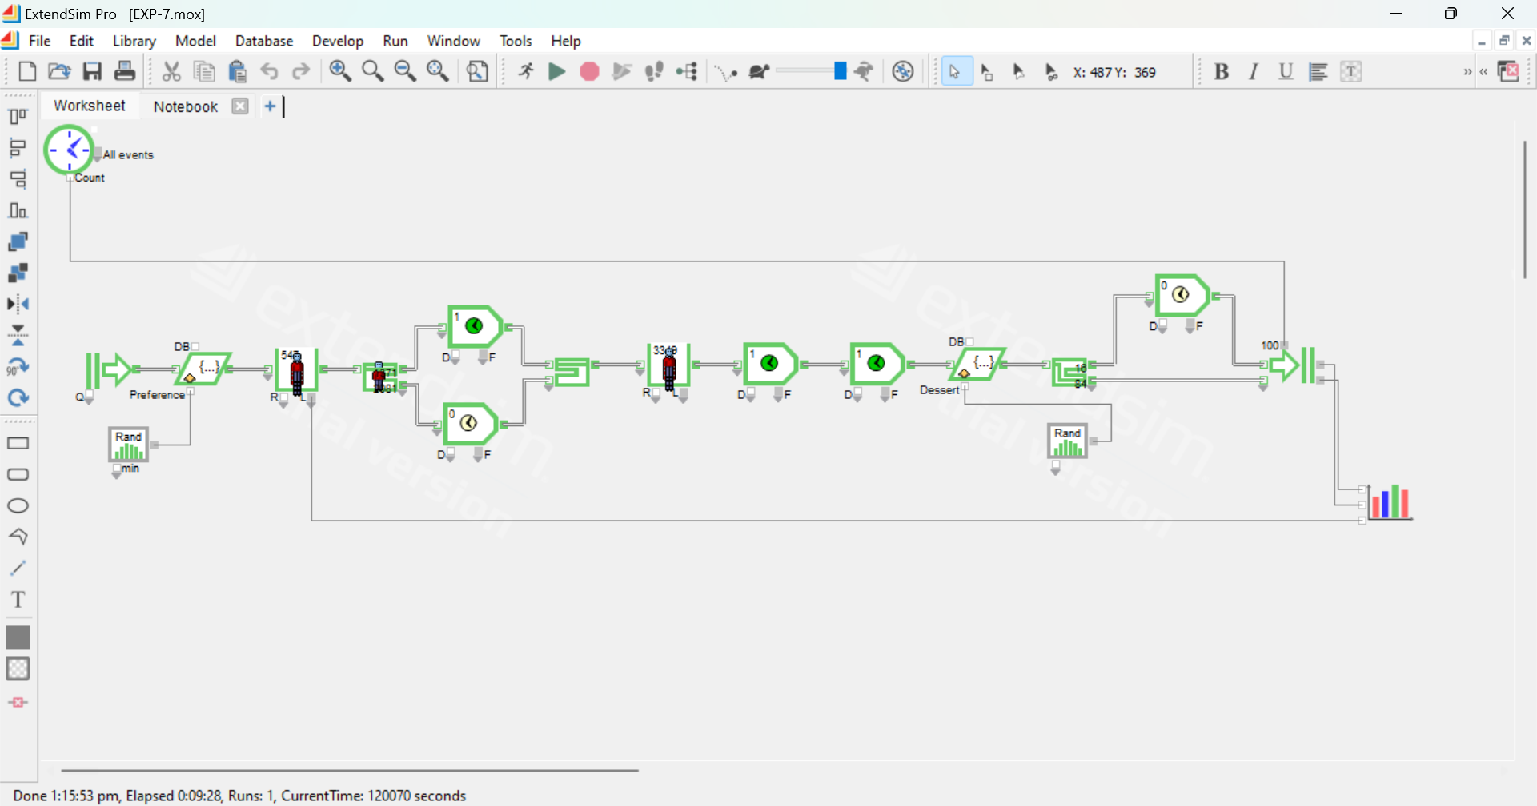

**Output**: *(Printed results i.e. the plotter data)*

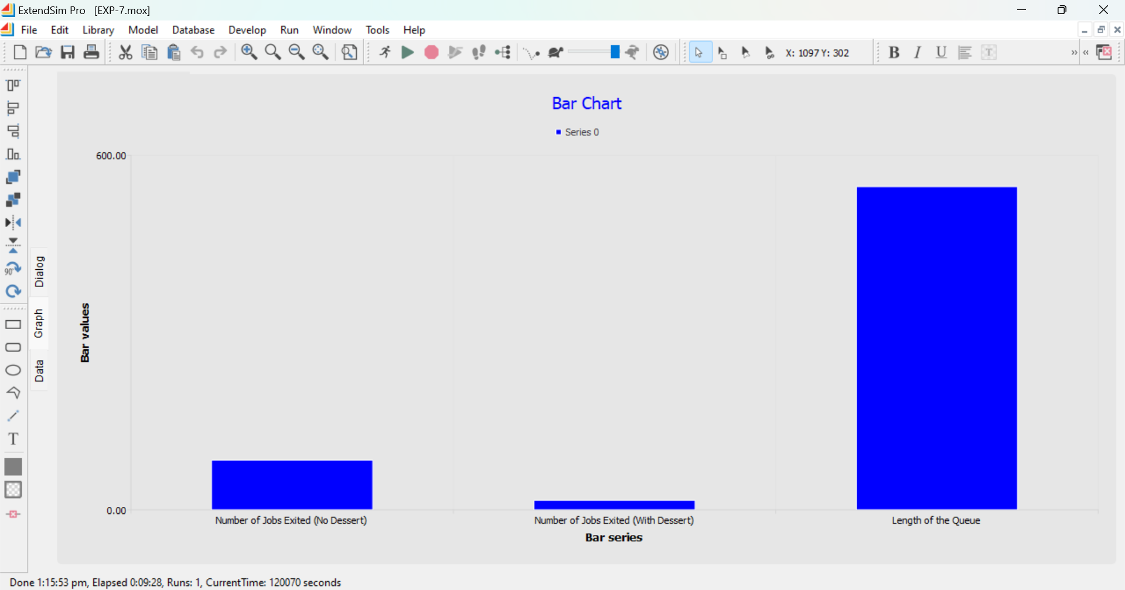

**__________________________________________________________________________**

**Questions:**

**1. List some features when selecting simulation software.**

* **Ease of Use:** Intuitive interface and user-friendly setup to easily model systems.
* **Customization:** Ability to customize various elements like arrival rates, service times, and routing.
* **Flexibility:** Support for different types of simulations (e.g., discrete event, Monte Carlo).
* **Visualization Tools:** Animation and graphing capabilities for clear representation of system behavior.
* **Performance Metrics:** Ability to collect and analyze data like queue lengths, waiting times, and server utilization.
* **Integration:** Compatibility with other software or databases for data input/output.
* **Scalability:** Can handle small to large models without significant performance degradation.
* **Support for Random Variables:** Built-in support for generating random variables for stochastic processes.

**2. Give the physical basis for selecting distribution.**

**(i) Poisson Distribution:** The Poisson distribution models the arrival of customers or events over time in a fixed interval. It is often used when events occur independently, and the average rate of occurrence is constant. In this case, the customers arrive at the cafeteria at a rate of one every 30 seconds, making the Poisson distribution suitable.

**(ii) Exponential Distribution:** The exponential distribution is commonly used to model the time between successive events in a Poisson process. It fits the service times and meal preparation times, where each event (service) is independent, and the service time is memoryless.

**(iii) Normal Distribution:** The normal distribution is used when the process involves a large number of independent random variables that combine to affect the outcome. It is commonly applied when data is symmetrically distributed, and values cluster around a mean. For example, customer service times or waiting times might follow a normal distribution when influenced by several factors.

**3. What is the purpose of Output analysis?**

The purpose of output analysis is to interpret and evaluate the results of a simulation model. It helps in assessing system performance based on the metrics collected during the simulation. The goal is to identify trends, bottlenecks, and inefficiencies in the system, and make informed decisions to improve system design, resource allocation, and overall performance. This analysis provides valuable insights that help optimize the system for real-world application.

**__________________________________________________________________________**

**Outcomes: CO3 — Analyze simulation results to reach an appropriate conclusion.**

**__________________________________________________________________________**

**Conclusion: (Conclusion to be based on outcomes)**

The simulation of the cafeteria system using Extend Sim has successfully provided insights into the queuing behavior of customers as they proceed through various stages of the cafeteria, such as arrival, counter selection, meal service, payment, and optional dessert. The model successfully tracks and animates customer movement and queuing, offering a dynamic visual representation of how the system performs as 100 customers exit the cafeteria. The collected data, such as the length of the queue and the number of jobs processed, can be analyzed for performance evaluation. The simulation helps assess the impact of varying parameters on system efficiency, enabling better decision-making for improving the cafeteria's operational design and service efficiency.

**__________________________________________________________________________**

**Grade: AA / AB / BB / BC / CC / CD / DD**

**Signature of faculty in-charge with date**

**__________________________________________________________________________**

**References:**

**Books/ Journals/ Websites:**

**Text Book:**

Banks J., Carson J. S., Nelson B. L., and Nicol D. M., “Discrete Event System Simulation”, 3rd edition, Pearson Education, 2001.

**Additional Web Resources:**

Extend sim Users Guide

* Real Queuing Examples: [http://www2.uwindsor.ca/hlynka/qreal.html](http://www2.uwindsor.ca/)

This site contains excerpts from news articles that deal with aspects of waiting lines.

* ClearQ: <http://clearq.com/>

This company produces “take-a-number” systems for service facilities (e.g., delis), but also provides performance information about the waiting line.

* Qmatic: <http://us.q-matic.com/index.html>

This company produces informational displays and other products to keep customers informed about waiting times.

* “Queuing Presentation” by Richard Larson, given at the Institute for Operations Research and the Management Sciences:

[http://caes.mit.edu/people/larson/MontrealINFORMS1/sld001.htm.](http://caes.mit.edu/people/larson/MontrealINFORMS1/sld001.htm)

* The Queuing Theory Tutor:

[http://www.dcs.ed.ac.uk/home/jeh/Simjava/queueing/mm1_q/mm1_q.html](http://www.dcs.ed.ac.uk/home/jeh/Simjava/queuei)

This site has two animated displays of waiting lines. The user can change arrival and service rates to see how performance is affected.

* Myron Hlynka’s Queuing Page: [http:www2.uwindsor.ca/hlynka/queue.html](http://www2.uwindsor.ca/hlynka/queue.html)

This Web site contains information about waiting lines as well as links to other interesting sites.

* Queuing ToolPak: <http://www.bus.ualberta.ca/aingolfsson/qtp/>

The Queuing ToolPak is an Excel add-in that allows you to easily compute performance measures for a number of different waiting line models.

**__________________________________________________________________________**